Seasonal temperature and flow drive spatial and temporal population dynamics in a native salmonid

Yoichiro Kanno^{* a}, Benjamin H. Letcher ^{b}, Nathaniel P. Hitt ^{c}, Elise F. Zipkin ^{d}, and David A. Boughton ^{e}
ª School of Agricultural, Forest, and Environmental Sciences, Clemson University, Clemson, SC, USA
^{b} Silvio O. Conte Anadromous Fish Research Center, United States Geological Survey, Turners Falls, MA, USA
^{c} Leetown Science Center, United States Geological Survey, Kearneysville, WV, USA
^{d} Department of Zoology, Michigan State University, East Lansing, MI, USA
^{e} Southwest Fisheries Science Center, National Oceanic and Atmospheric Administration, La Jolla, CA, USA
* Corresponding author: ykanno@clemson.edu

Summary

- Density dependence + density independence regulate animal population dyanmics. Understanding this knowledge is important for assessing climate change

- In this study, we investigated effects of air temperature and flow during fall, winter and spring on survival and recruitment of brook trout (Salvelinus fontinalis) by applying a multi-state population model to a 15-year fish count record collected from 72 sites in Shenandoah National Park, Virginia, USA.

- Summaries should be understandable in isolation from your article.

- Summaries should only have 5 points, ideally, listing; (1) what the question is, (2) why it is interesting, (3) what was done in the study, (4) what was found and (5) what this means.

- Advice for optimising your Summary/Abstract (and Title) so that your paper is more likely to be found in online searches is provided at http://www.blackwellpublishing.com/bauthor/seo.asp

- This should summarise the main results and conclusions of the paper using simple, factual, numbered statements. It must not exceed 350 words.

- Summaries/abstracts are key to getting people to read your article.

- Summaries should be understandable in isolation from your article.

- Summaries should only have 5 points, ideally, listing; (1) what the question is, (2) why it is interesting, (3) what was done in the study, (4) what was found and (5) what this means.

- Advice for optimising your Summary/Abstract (and Title) so that your paper is more likely to be found in online searches is provided at http://www.blackwellpublishing.com/bauthor/seo.asp

Key-words climate change, hierarchical models, Salvelinus fontinalis, stock-recruitment relationship, streams, survival

Introduction

Climate influences vital population rates and this is the mechanism through which species range and abundance will be affected by climate change (Wright et al. 2009; Hegel et al. 2010; Nilsson et al. 2011). Understanding climate effects on population vital rates is a pre-requisite to an accurate assessment of animal responses to future climate change. Research on climate-animal relationships should incorporate seasonal effects on vital rates because an alteration of a key environmental (e.g. temperature increase) may have different effects on vital rates during different seasons and a net effect on population growth is not apparent by assessing a single season (Diamond et al. 2013; Dybala et al. 2013). Assessing through the annual cycle indeed reveals important seasonal drivers of population dynamics (Wright et al. 2009; Fernández-Chacón et al. 2011). Knowledge on seasonal effects requires long-term data sets, which are few in animal population studies.
Studying seasonal climate influences on animal populations is further complicated by several reasons. First, demographic parameters typically differ along environmental gradients (Letcher et al. 2007; Jenouvrier et al. 2009). This suggests that the impact of climate drivers varies over space (Fernández-Chacón et al. 2011) and understanding such spatial heterogeneity is much needed for conservation planning. Second, different life stages of a population respond differently to the same climate condition. It is typical that survival rates vary among size classes in the same environment (Diamond et al. 2013; Dybala et al. 2013). Finally, animal populations are regulated by density-dependent factors, as well as density-independent (environmental) factors. Density-dependence has been observed in recruitment (Diamond et al. 2013) and survival (Lok et al. 2013) in animal populations, and the strength of density-dependence affects the population stability and resiliency (Lack 1954).
These issues pose a difficult challenge in designing and analysing survey data of animal populations, particularly for cryptic species in which individual detection is far from perfect and vital rates are hard to observe. Mark-recapture methods have been most commonly employed in inferring demographic rates (Williams, Nichols & Conroy 2002). A caveat of mark-recapture studies is that their expensive and labour-intensive nature does not typically allow for conducting fieldwork at a number of sites. Recording animal counts is less labour-intensive and it allows the researcher to collect spatially and temporally replicated data. But count data are considered to contain more sparse information on demographic rates and they have been used less frequently in demographic analysis of animal populations (e.g. Gross, Craig & Hutchison 2002; Link, Royle & Hatfield 2003). However, the recent advance in analysis of unmarked data may provide a promising approach to understanding seasonal climate effects on population dynamics. Dail & Madsen (2011) proposed a statistical approach that models apparent survival and recruitment rates based on count data replicated over space and time. This method was further extended by Zipkin et al. (in press) who demonstrated that demographic heterogeneity among stages (e.g. age, size and sex) could be modelled in the Dail-Madsen framework. This type of multi-state population models provides a flexible framework in which temporal and spatial heterogeneity in the environment as well as density-dependent processes can be effectively incorporated in the analysis of unmarked data.
In this study, we investigated effects of air temperature and stream flow during fall, winter and spring on survival and recruitment of brook trout (Salvelinus fontinalis) using a 15-year fish count record collected from 72 sites in Shenandoah National Park, Virginia, U.S. Stream temperature and flow are the key drivers of fish population dynamics (Poff et al. 1997; Arismendi et al. 2013), and numerous studies have shown that stream fish populations are affected by average and extreme conditions of these key environmental covariates (e.g. Roghair, Dolloff & Underwood 2002; Perry & Bond 2009; Xu, Letcher & Nislow 2010a). Stream temperature and flow will be affected by climate change via alterations in air temperature and precipitation regimes (Novotny & Stefan 2007; Huntington et al. 2009). Consequently, there is a great need for understanding temperature and flow effects on population dynamics of stream fish, particularly for southern populations of a coldwater species such as brook trout.
Our objectives were two-fold. The first objective was to develop a multi-state population model to assess the effects of seasonal temperature and flow on demographic rates while accounting for variation among size classes and space, and density-dependence in recruitment. The majority of previous stream fish studies focused on the effects of summer conditions on demographic rates (Boss & Richardson 2002; Xu, Letcher & Nislow 2010a), and much less is known about other seasons (e.g. Jensen & Johnsen 1999; Berger & Gresswell 2009). Our second objective was to use the multi-state model to explore the effect of deleterious seasons and years in simulations. We sought to understand brook trout population responses to extreme climate events because the frequency and magnitude of such events are projected to increase under climate change (Rummukainen 2013). By addressing the two study objective, we demonstrate the utility of spatially and temporally replicated animal abundance data (without mark-recapture data) in understanding key seasonal effects on population vital rates and abundance.

Materials and methods

STUDY SPECIES
The brook trout is native to north-eastern North America, ranging from Georgia, U.S. to Labrador and Quebec, Canada. They inhabit clear and cold waters, and stream temperature is a major factor affecting their distribution and abundance (Hartman & Cox 2008; McKenna & Johnson 2011). Stream flow has also been shown to affect brook trout populations (Roghair, Dolloff & Underwood 2002; Xu, Letcher & Nislow 2010a).
Brook trout populations have declined greatly due to a combination of anthropogenic activities, particularly at the southern range where they currently occur at high-elevation streams along the Appalachian Mountains (Hudy et al. 2008). Brook trout in headwater streams are typically short-lived (< 3-4 years old) and can reproduce at small body size (< 100 mm) (Grossman et al. 2010; Xu, Letcher & Nislow 2010b; Kanno et al. 2012). Brook trout spawn during autumn and females excavate small depressions called “redds” in which fertilized eggs remain until late winter to early spring. A majority of body growth takes place during spring (March-June) in a stream located at the northern portion of the U.S. range (Xu, Letcher & Nislow 2010b). Microhabitat preferences change through ontogeny. Young-of-year (YOY) individuals that are < 1 year old are more common in tributaries and at shallow depths, but larger trout prefer deeper and slower sections of streams such as pools (Kanno et al. 2012; Anglin & Grossman 2013).

FISH DATA
We used a portion of a long-term monitoring data set collected by the National Park Service during 1996-2010 at 72 sites in the Shenandoah National Park, Virginia, USA (Fig. 1). The study area lies within the Blue Ridge physiographic region represented by steep slopes, narrow ridges and high relief. Elevation of 72 sites ranged from 285 to 802 m (median = 436 m). Sites are located on small headwater streams (first- to third-order) that are well-shaded by riparian vegetation and are generally characterized with step-pool or cascade habitats. Stream flow typically peaks in spring followed by low-flow conditions in late summer to fall. Study sites typically harbour few fish species and common species include blacknose dace (Rhinichthys atratulus), mottled sculpin (Cottus bairdi) and fantail darter (Etheostoma flabellare).
Each study site was approximately 100 m in stream length. Upstream and downstream ends of sites were typically bounded by natural geomorphic habitat breaks that impede fish movement (e.g. step pools), and they were marked permanently on the stream bank. Brook trout were surveyed between May and August (mostly June to August) during 1996-2010. Only two out of 72 sites were surveyed annually during the 15-year study period, and as few as three visits were made at 15 sites. As a result, the data set contained missing occasions and this is typical of long-term ecological data collected at multiple sites.
Consistent field protocols using backpack electrofishing were applied to standardize sampling effort across study sites. Three-pass depletion surveys were conducted to infer fish capture probabilities on most sampling occasions (84 %, or 514 out of 611 occasions), but single-pass surveys were conducted otherwise. Fish movement in and out of sites were prevented because most site boundaries coincided with natural geomorphic breaks and they were supplemented by constructing cobble dams. Block nets were used when this approach was not successful. The number of electrofishers used depended on stream width and it ranged 1-3 electrofishers among sites. Each electrofisher was accompanied by two netters and sampling crews proceeded upstream by sampling all available habitats carefully. Captured fish were measured for total length (± 1 mm) and weight (± 0.1 g), and returned to the stream alive. YOY individuals can be distinguished from older individuals (“adults” hereafter) based on length-frequency distributions in brook trout populations (Xu, Letcher & Nislow 2010b; Kanno et al. 2012), and this was also the case for brook trout populations in Shenandoah National Park. Thus, fish count data were available by site, year, fish size (YOY or adults) and electrofishing pass.

TEMPERATURE AND FLOW DATA
We characterized seasonal mean air temperature and stream flow conditions experienced by the study area. Seasons were defined as fall (September-November), winter (December-February) and spring (March-May). Summer temperature and flow were not characterized because this is the period in which fish surveys took place (see above). We used air temperature and stream flow data from a single location in the Shenandoah National Park by assuming that they represent regional environmental conditions and can adequately characterize temporal variation in climate.
Air temperature data at the Shenandoah National Park (38º5333´ N, 78º3500´ W) were derived from the Daymet database (http://daymet.ornl.gov). The Daymet model generates long-term daily maximum and minimum air temperature values at the resolution of 1 km². We used daily maximum air temperature values to calculate seasonal mean maximum air temperature (hereafter ‘seasonal air temperature’). Stream flow data were derived from a gaging station maintained by the National Park Service as part of the Shenandoah Watershed Study program (http://swas.evsc.virginia.edu/). The gaging station was in the White Oak Run located at the southern part of the Shenandoah National Park (Fig. 1). Seasonal mean discharge was calculated from daily discharge values.

STATISTICAL ANALYSIS
We examined the effects of seasonal temperature and flow on demographic rates by using a state-structured open population N-mixture model (Zipkin et al. in press). Classic N-mixture models estimate population abundance at a set of local sites over a time period in which the total population is assumed to be closed (Royle 2004). Abundance estimates are made possible by employing a repeated sampling scheme that infers the capture probability of individuals. Dail & Madsen (2011) extended N-mixture models to open populations in which the population size changes over time due to a survival process and a “gains” process (recruitment and immigration). Their approach has been further extended for more ecologically realistic situations in which individual heterogeneity within a population, as represented by size, age or sex, is accounted for (Zipkin et al. in press). This model provides inferences on state-specific vital rates as well as abundance estimates.
We assumed an annual population model of brook trout in the Shenandoah National Park comprised of two age classes; YOY and adults (Fig. 2). A portion of YOY individuals at a local site survive annually and transition into the adult class. Those adults that survive remain in the same state. YOY and adults experience different annual survival probabilities, as represented by ω₁ (YOY) and ω₂ (adults) in the life cycle diagram (Fig. 2). Survival of brook trout typically differs by body size in other populations (Petty, Lamothe & Mazik 2005; Letcher et al. 2007). Brook trout mature at a small body size (< 100 mm, Hudy et al. 2010; Kanno, Vokoun & Letcher 2011) and we assumed that adults are capable of reproducing offspring. We assumed that sites were independent of each other. It should be stressed that we did not specifically model immigration and emigration based on the assumption of no net dispersal in and out of a local site. This was a plausible assumption because a local site was established at a representative section of a stream, and therefore we did not consider that the local site did not differ greatly from adjacent stream sections. Immigration can be specifically modelled in the state-structured open population N-mixture model (Zipkin et al. in press), but we found that the inference on immigration term is highly sensitive to a slight change in model specifications in our data set as well as simulations (Y. Kanno & D.A. Boughton, unpublished data).
We define our count data, y_{i,t,a,k}, as the observed count of individuals at site i in year t for age class a and electrofishing pass k. Our main interest is to infer demographic rates that govern the spatial and temporal variation in N_{i,t,a}, the true age-specific abundance for each site and year. The population abundance for YOY (a = 1) and adults (a = 2) in the first year of sampling was assumed to follow a Poisson distribution such that N_{i,1,a} ~ Pois(λ_{a}) for all sampling sites {i = 1,…,72}. In subsequent years (t ≥ 2), population size was modelled by demographic processes according to the life cycle of the brook trout population (Fig. 2). Specifically, recruitment was
Survival was
two independent quantities were considered; S_{i,t,a} denotes the number of individuals in age class a at site i that survive from year t–1 to year t, and

Results
This should state the results, drawing attention in the text to important details shown in tables and figures.

Discussion
This should point out the significance of the results in relation to the reasons for doing the work, and place them in the context of other work.

Acknowledgements
Virginia folks who collected data. An earlier version of this manuscript was greatly improved by constructive comments by XXX.

References
Anglin, Z.W. & Grossman, G.D. (2013) Microhabitat use by southern brook trout (Salvelinus fontinalis) in a headwater North Carolina stream. Ecology of Freshwater Fish, 22, 567-577.
Arismendi, I., Johnson, S.L., Dunham, J.B. & Haggerty, R. (2013) Descriptors of natural thermal regimes in streams and their responsiveness to change in the Pacific Northwest of North America. Freshwater Biology, 58, 880-894.
Berger, A.M. & Gresswell, R.E. (2009) Factors influencing coastal cutthroat trout (Oncorhynchus clarkii clarkii) seasonal survival rates: a spatially continuous approach within stream networks. Canadian Journal of Fisheries and Aquatic Sciences, 66, 613-632.
Boss, S.M. & Richardson, J.S (2002) Effects of food and cover on the growth, survival, and movement of cutthroat trout (Oncorhynchus clarki) in coastal streams. Canadian Journal of Fisheries and Aquatic Sciences, 59, 1044-1053.
Dail, D. & Madsen, L. (2011) Models for estimating abundance from repeated counts of an open metapopulation. Biometrics, 67, 577-587.
Diamond, S.L., Murphy, C.A. & Rose, K.A. (2013) Simulating the effects of global climate change on Atlantic croaker population dynamics in the mid-Atlantic Region. Ecological Modelling, 264, 98-114.
Dybala, K.E., Eadie, J.M., Gardali, T., Seavy, N.E. & Herzog, M.P. (2013) Projecting demographic responses to climate change: adult and juvenile survival respond differently to direct and indirect effects of weather in a passerine population. Global Change Biology, 19, 2688-2697.
Fernández-Chacón, A., Bertolero, A., Amengual, A., Tavecchia, G., Homar, V. & Oro, D. (2011) Spatial heterogeneity in the effects of climate change on the population dynamics of a Mediterranean tortoise. Global Change Biology, 17, 3075-3088.
Gross, K., Craig, B.A. & Huchison, W.D. (2002) Bayesian estimation of a demographic matrix model from stage-frequency data. Ecology, 83, 3285-3298.
Grossman, G.D., Ratajczak, R.E., Wagner, C.M. & Petty, J.T. (2010) Dynamics and regulation of the southern brook trout (Salvelinus fontinalis) population in an Appalachian stream. Freshwater Biology, 55, 1494-1508.
Hartman, K.J. & Cox, M.K. (2008) Refinement and testing of a brook trout bioenergetics model. Transactions of the American Fisheries Society, 137, 357-363.
Hegel, T.M., Mysterud, A., Ergon, T., Loe, L.E., Huettmann, F. & Stenseth, N.C. (2010) Seasonal effects of Pacific-based climate on recruitment in a predator-limited large herbivore. Journal of Animal Ecology, 79, 471-482.
Hudy, M., Thieling, T.M., Gillespie, N. & Smith, E.P. (2008) Distribution, status, and land use characteristics of subwatersheds within the native range of brook trout in the eastern United States. North American Journal of Fisheries Management, 28, 1069-1085.
Hudy, M., Coombs, J.A., Nislow, K.H. & Letcher, B.H. (2010) Dispersal and within-stream spatial population structure of brook trout revealed by pedigree reconstruction. Transactions of the American Fisheries Society, 139, 1276-1287.
Huntington, T.G., Richardson, A.D., McGuire, K.J. & Hayhoe, K. (2009) Climate and hydrological changes in the northeastern United States: recent trends and implications for forested and aquatic ecosystems. Canadian Journal of Forest Research, 39, 199-212.
Jenouvrier, S., Thibault, J.C., Viallefont, A., Vidals, P., Ristow, D., Mougin, J.L., Brichetti, P., Borg, J.J. & Bretagnolle, V. (2009) Global climate patterns explain range-wide synchrony in survival of a migratory bird. Global Change Biology, 15, 268-279.
Jensen, A.J. Johnsen, B.O. (1999) The functional relationship between peak spring floods and survival and growth of juvenile Atlantic salmon (Salmo salar) and brown trout (Salmo trutta). Functional Ecology, 13, 778-785.
Kanno, Y., Vokoun, J.C. & Letcher, B.H. (2011) Sibship reconstruction for inferring mating systems, dispersal and effective population size in headwater brook trout (Salvelinus fontinalis) populations. Conservation Genetics, 12, 619-628.
Kanno, Y., Vokoun, J.C., Holsinger, K.E. & Letcher, B.H. (2012) Estimating size-specific brook trout abundance in continuously sampled headwater streams using Bayesian mixed models with zero inflation and overdispersion. Ecology of Freshwater Fish, 21, 404-419.
Lack, D. (1954) The Natural Regulation of Animal Numbers. Clarendon Press, Oxford, UK.
Letcher, B.H., Nislow, K.H., Coombs, J.A., O’Donnell, M.J. & Dubreuil, T.L. (2007) Population response to habitat fragmentation in a stream-dwelling brook trout population. PLoS One, 2(11), e1139.
Link, W.A., Royle, J.A. & Hatfield, J.S. (2003) Demographic analysis from summaries of an age-structured population. Biometrics, 59, 778-785.
Lok, T., Overdijk, O., Tinbergen, J.M. & Piersma, T. (2013) Seasonal variation in density dependence in age-specific survival of a long-distance migrant. Ecology, 94, 2358-2369.
McKenna, J.E., Jr. & Johnson, J.H. (2011) Landscape models of brook trout abundance and distribution in lotic habitat with field validation. North American Journal of Fisheries Management, 31, 742-756.
Nilsson, A.L.K., Knudsen, E., Jerstad, K., Røstad, O.W., Walseng, B., Slagsvold, T. & Stenseth, N.C. (2011) Climate effects on population fluctuations of the white-throated dipper Cinclus cinclus. Journal of Animal Ecology, 80, 235-243.
Novotny, E.V. & Stefan, H.G. (2007) Stream flow in Minnesota: indicator of climate change. Journal of Hydrology, 334, 319-333.
Perry, G.L.W. & Bond, N.R. (2009) Spatially explicit modelling of habitat dynamics and fish populations persistence in an intermittent lowland stream. Ecological Applications, 19, 731-746.
Petty, J.T., Lamothe, P.J. & Mazik, P.M. (2005) Spatial and seasonal dynamics of brook trout populations inhabiting a central Appalachian watershed. Transactions of the American Fisheries Society, 134, 572-587.
Poff, N.L., Allan, J.D., Bain, M.B., Karr, J.R., Prestegaard, K.L., Richter. B.D, Sparks, R.E. & Stromberg, J.C. (1997) The natural flow regime: a new paradigm for river conservation and restoration. BioScience, 47, 769-784.
Roghair, C.N., Dolloff, C.A. & Underwood, M.K. (2002) Response of a brook trout population and instream habitat to a catastrophic flood and debris flow. Transactions of the American Fisheries Society, 131, 718-730.
Royle, J.A. (2004) N-mixture models for estimating population size from spatially replicated counts. Biometrics, 60, 108-115.
Rummukainen, M. (2013) Climate change: changing means and changing extremes. Climatic Change, 121, 3-13.
Williams, B.K., Nichols, J.D. & Conroy, M.J. (2002) Analysis and Management of Animal Populations. Academic Press, San Diego, California, USA.
Wright, L.J., Hoblyn, R.A., Green, R.E., Bowden, C.G.R., Mallord, J.W., Sutherland, W.J. & Dolman, P.M. (2009) Importance of climatic and environmental change in the demography of a multi-brooded passerine, the woodlark Lullula arborea. Journal of Animal Ecology, 78, 1191-1202.
Xu, C., Letcher, B.H. & Nislow, K.H. (2010a) Size-dependent survival of brook trout Salvelinus fontinalis in summer: effects of water temperature and stream flow. Journal of Fish Biology, 76, 2342-2369.
Xu, C., Letcher, B.H. & Nislow, K.H. (2010b) Context-specific influence of water temperature on brook trout growth rates in the field. Freshwater Biology, 55, 2253-2264.
Zipkin, E.F., Thorson, J.T., See, K., Lynch, H.J., Grant, E.H.C., Kanno, Y., Chandler, R.B., Letcher, B.H., Royle, J.A. (in press) Modeling structured population dynamics using data from unmarked individuals. Ecology.

Otto, S.P. & Day, T. (2007) A Biologist's Guide to Mathematical Modeling in Ecology and Evolution. Princeton University Press, Princeton, New Jersey, USA.
Conway. G. (2007) A Doubly Green Revolution: ecology and food production. Theoretical Ecology: Principles and Applications, 3rd edn (eds R. May & A. McLean), pp. 158–171. Oxford University Press, Oxford.

Stevenson, I.R. (1994) Male-biased mortality in Soay sheep. PhD thesis, University of

References should only be cited as 'in press' if the paper has been accepted for publication. Other references should be cited as 'unpublished' and not included in the list. Work not yet accepted for publication may be cited in the text and attributed to its author as: author name (including initials), unpublished data. In press articles should be uploaded with the manuscript as ‘supplementary files’.

Scientific names
Give the Latin names of each species in full, together with the authority for its name, at first mention in the main text. If they appear in the Summary/Abstract, use the common and Latin name only in the first instance, then the Latin or common name thereafter. If there are many species, cite a Flora or checklist which may be consulted for authorities instead of listing them in the text. Do not give authorities for species cited from published references. Give priority to scientific names in the text (with colloquial names in parentheses, if desired).

Mathematical material
Mathematical expressions should be carefully represented. Suffixes and operators such as d, log, ln and exp will be set in Roman type; matrices and vectors will be set in bold type; other algebraic symbols will be set in italic. Make sure that there is no confusion between similar characters like 'l' (ell) and '1' (one). Also make sure that expressions are spaced as you would like them to appear, and if there are several equations they should be identified by eqn 1, etc.

Numbers in tables
Do not use an excessive number of digits when writing a decimal number to represent the mean of a set of measurements (the number of digits should reflect the precision of the measurement).

Numbers in text
Numbers from one to nine should be spelled out except when used with units; e.g. two eyes but 10 stomata and 5°C.

Figures
The publishers would like to receive your artwork in electronic form. Please save vector graphics (e.g. line artwork) in Encapsulated Postscript Format (EPS), and bitmap files (e.g. half-tones) in Tagged Image File Format (TIFF). Ideally, vector graphics that have been saved in a metafile (.WMF) or pict (.PCT) format should be embedded within the body of the text file. Detailed information on the Wiley-Blackwell digital illustration standards is available at:
http://www.blackwellpublishing.com/bauthor/illustration.asp

Figures should not be boxed (superfluous bounding axes) and tick marks must be on the inside of the axes. Where possible, figures should fit on a single page in the submitted paper. In a final version they will generally be reduced in size by about 50% during production. Wherever possible, they should be sized to fit into a single column width (c. 70mm final size). To make best use of space, you may need to rearrange parts of figures (e.g. so that they appear side by side). Please ensure that symbols, labels, etc. are large enough to allow reduction to a final size of c. 8 point, i.e. capital letters will be about 2 mm tall. Lettering should use a sans serif font (e.g. Helvetica and Arial) with capitals used for the initial letter of the first word only. Bold lettering should not be used. Units of axes should appear in parentheses after the axis name. Please note that line figures should be at least 600 dpi and half-tones (photos) should be at least 300 dpi.

Images in the printed version of the Journal of Animal Ecology are in black and white as it is the policy of the Journal of Animal Ecology for authors to pay the full cost for colour paper print reproduction (currently £150 for the first figure, £50 thereafter). Free colour reproduction is available for the on line version: if authors require this, they should write their figure legend to accommodate both versions of the figure, and indicate their colour requirements on the Colour Work Agreement Form. This form should be completed in all instances where authors require colour, whether in print or online. Therefore, at acceptance, please download the form and return it to the Production Editor (Penny Baker, Wiley-Blackwell, John Wiley & Sons, 9600 Garsington Road, Oxford OX4 2DQ, UK. Please note that the ORIGINAL HARDCOPY form must be returned in all instances (a faxed or scanned version cannot be accepted). Please note that if you require colour content your paper cannot be published until this form is received.

Figure legends
Legends should be grouped on a separate sheet. Furnish enough detail so that the figure can be understood without reference to the text. In the full-text online edition of the journal, figure legends may be truncated in abbreviated links to the full screen version. Therefore, the first 100 characters of any legend should inform the reader of key aspects of the figure. Figures should be referred to in the text as Fig. 1, etc. (note Figs 1 and 2 with no period).

Tables
These should be referred to in the text as Table 1, etc. Do not present the same data in both figure and table form. Each table should be on a separate page, numbered and accompanied by a title at the top.

Supporting Information
Journal of Animal Ecology rarely publishes Appendices in the printed version. However, Supporting Information that is referred to in the text may be made available in the online version of the article. Guidelines for the preparation of Supporting Information are available here.

For the printed version, any Appendices should be listed under 'Supporting Information', and added after the References, with the opening statement: 'The following Supporting Information is available for this article online' followed by brief captions for the Appendices/Figs/Tables to be included. These should be numbered Appendix S1, Fig. S1, Table S1, etc.

Any literature referred to in the Appendix or online Supporting Information should also be referenced in the Appendix or online Supporting Information so that it is a self-contained piece of work. This may mean duplicating references if any literature is cited in both the main text and the Supporting Information.

All Supporting Information should be submitted online as part of the main manuscript. Please name your online supporting files as ‘online supporting information' and upload them with the main document. This allows the submission web site to combine all the relevant files together but keep them separate when it comes to publication stage.

Tables
Table 1. Summary of temporal and spatial covariates (mean, range, etc.)

Table 2. Parameter estimates from the model. Some key covariates are in bold for survival, recruitment, detection probability and initial abundance.
 | Parameters | Names in JAGS code | Median values (95 % CI)
YOY survival
 | mean survival | omega.mean[1] | 0.319 (0.311, 0.327)
 | fall flow | omega.b[1,1] | 0.283 (0.216, 0.354)
 | winter flow | omega.b[1,2] | -0.085 (-0.138, -0.041)
 | spring flow | omega.b[1,3] | 0.121 (0.080, 0.169)
 | spring temperature | omega.b[1,4] | 0.349 (0.309, 0.395)
 | elevation | omega.b[1,5] | 0.078 (0.047, 0.110)
Adult survival
 | mean survival | omega.mean[1] | 0.453 (0.441, 0.465)
 | fall flow | omega.b[1,1] | -0.237 (-0.284, -0.186)
 | winter flow | omega.b[1,2] | 0.141 (0.068, 0.205)
 | spring flow | omega.b[1,3] | -0.374 (-0.430, -0.324)
 | spring temperature | omega.b[1,4] | 0.302 (0.251, 0.360)
 | elevation | omega.b[1,5] | 0.342 (0.304, 0.381)
Per capita recruitment
 | fall flow | gamma.b[1] | 0.524 (0.510, 0.537)
 | winter flow | gamma.b[2] | -0.379 (-0.394, -0.364)
 | spring flow | gamma.b[3] | -0.005 (-0.022, 0.010)
 | spring temperature | gamma.b[4] | -0.154 (-0.166, -0.141)
 | elevation | gamma.b[5] | -0.075 (-0.087, -0.065)
Ricker stock-recruitment relationship
alpha |  | alpha | 1.002 (0.969, 1.034)
beta |  | beta | 0.0075 (0.0071, 0.0078)
Detection probability
 | mean detection probability of YOY | p.mean[1] | 0.511 (0.505, 0.519)
 | mean detection probability of adults | p.mean[2] | 0.631 (0.624, 0.639)
 | Julian date | p.b[1] | 0.179 (0.159, 0.199)
 | Stream width | p.b[2] | -0.140 (-0.159, -0.119)
Initial abundance
 | Abundance of YOY | lambda[1] | 38.1 (36.2, 40.2)
 | Abundance of adults | lambda[2] | 47.7 (45.6, 49.8)

Figures (to be replaced)

Fig. 1.

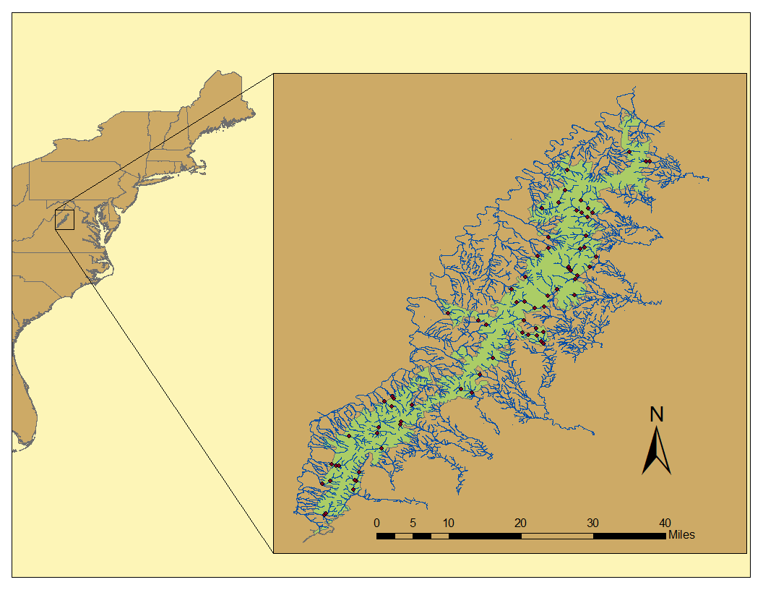

Fig. 2. Annual life cycle diagram

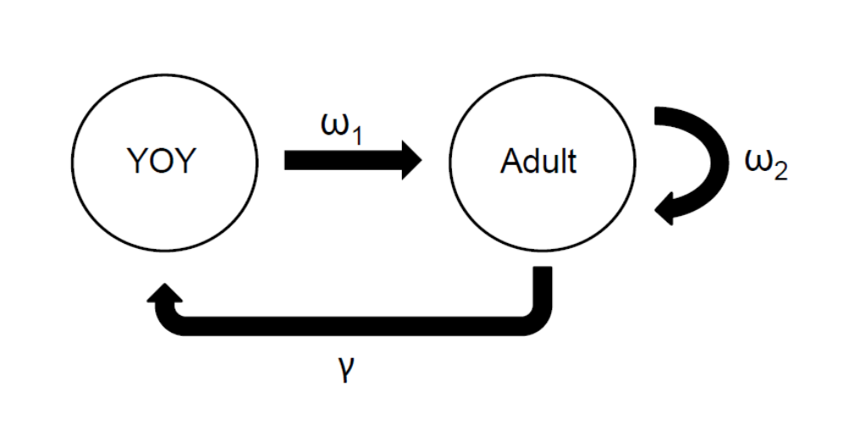
Fig. 3. Age-specific total abundance over time

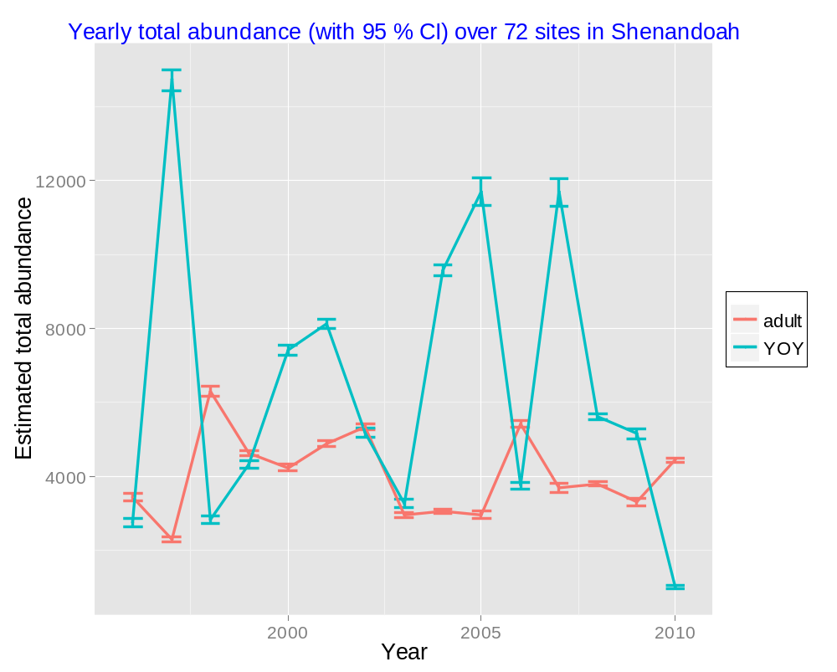
Fig. 4. Stock-recruitment relationship

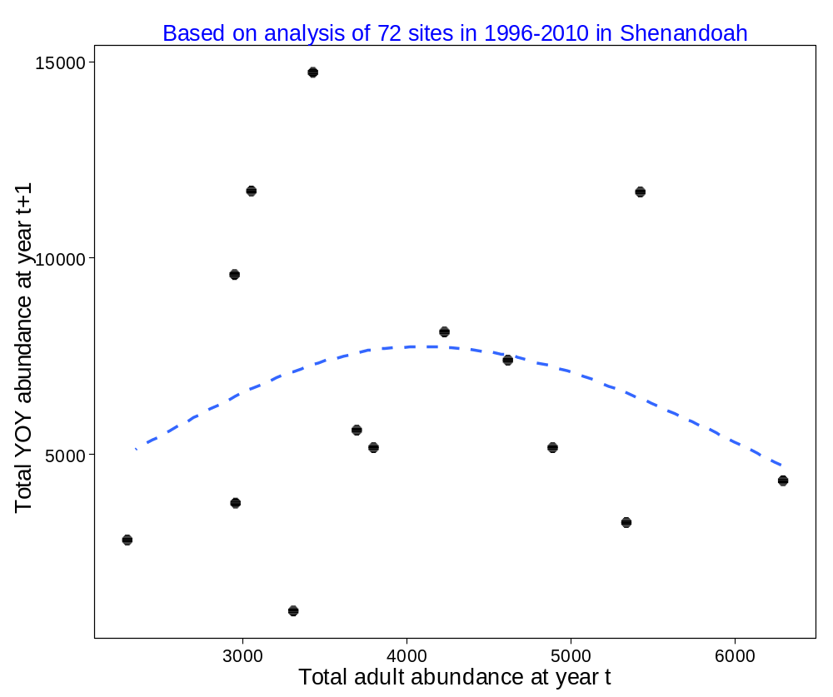
Fig. 5. Total YOY abundance at year t versus total adult abundance at year t+1
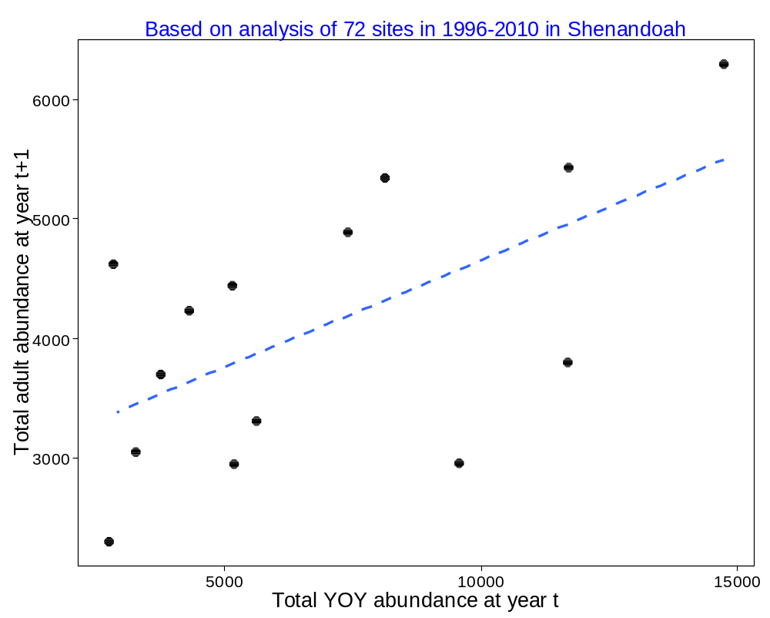

Fig. 6. Projections under some constant seasonal environmental conditions
(a) Fall flow
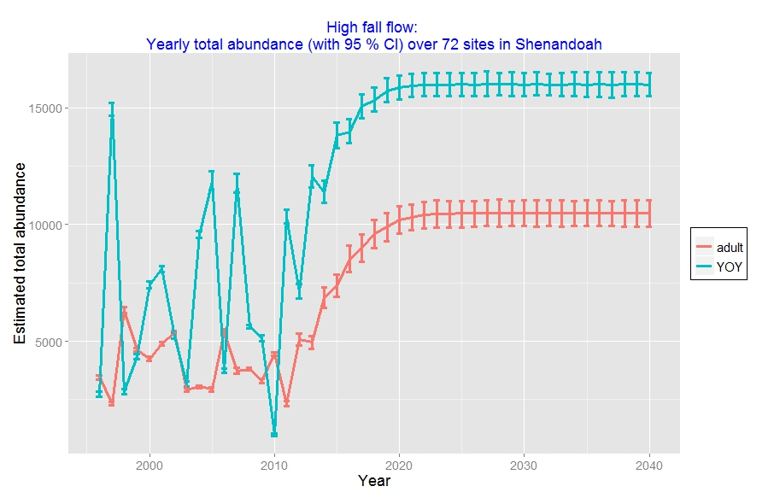
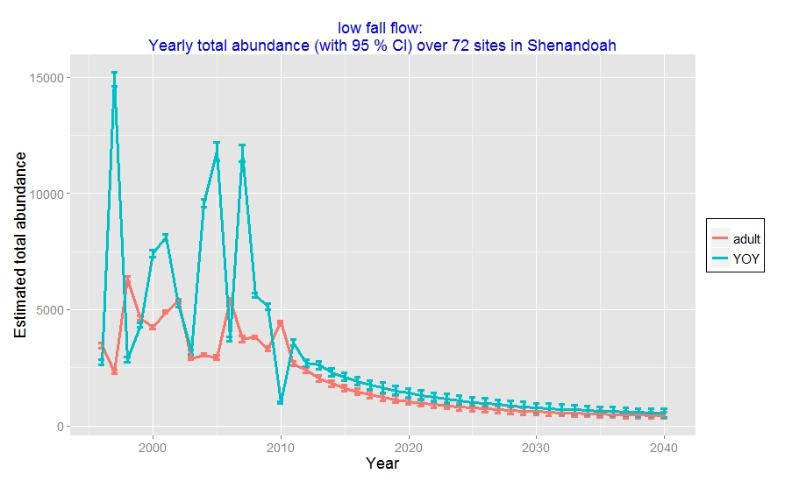
(b) Winter flow
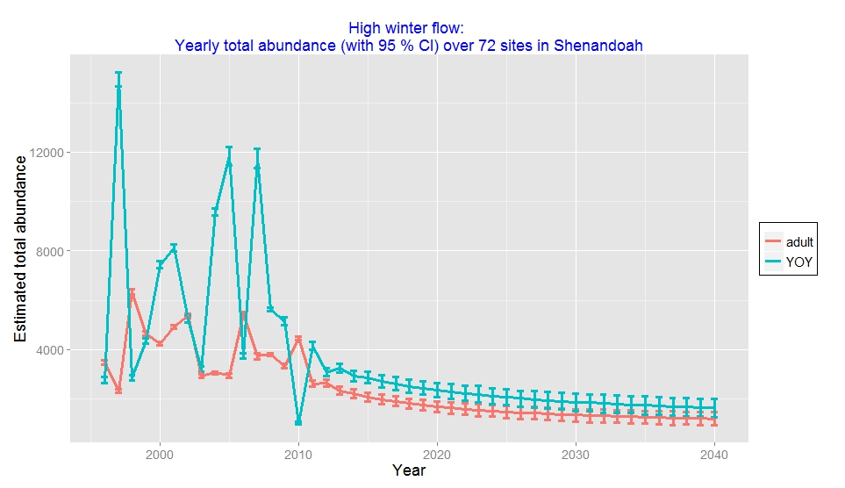
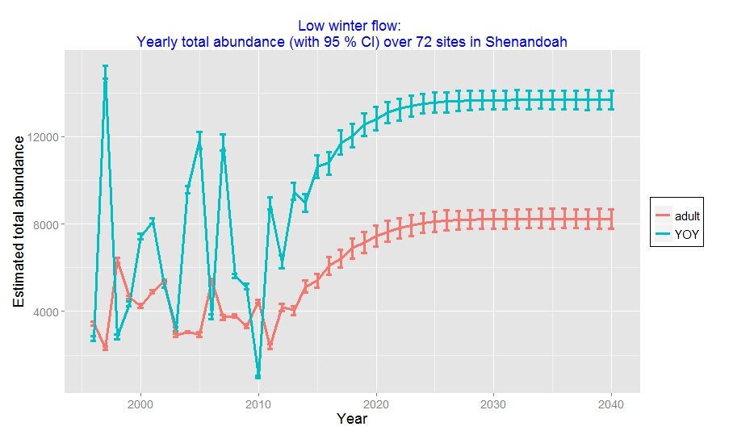

(c) spring flow
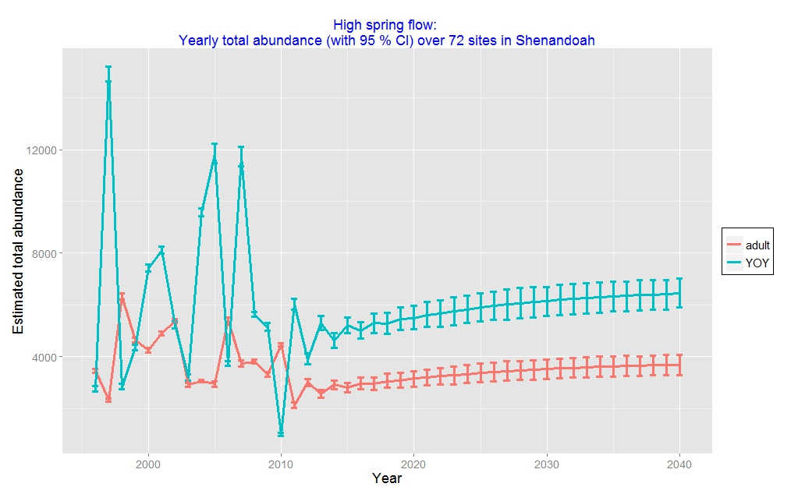

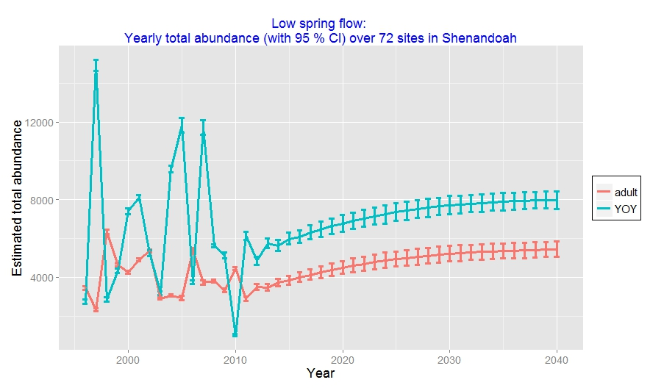

(d) spring temperature
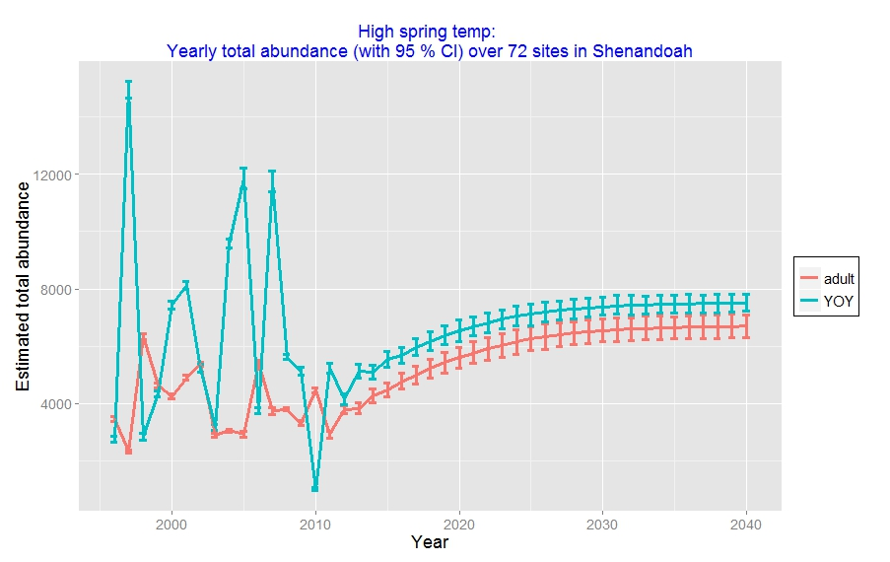
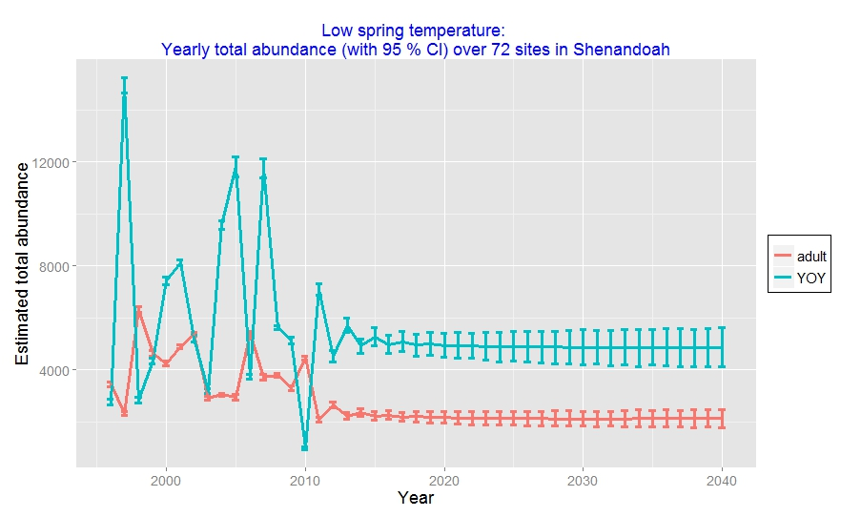
Fig. 7. Spatial variation under “detrimental” environmental conditions (each line represents each site)
(a) High winter flow
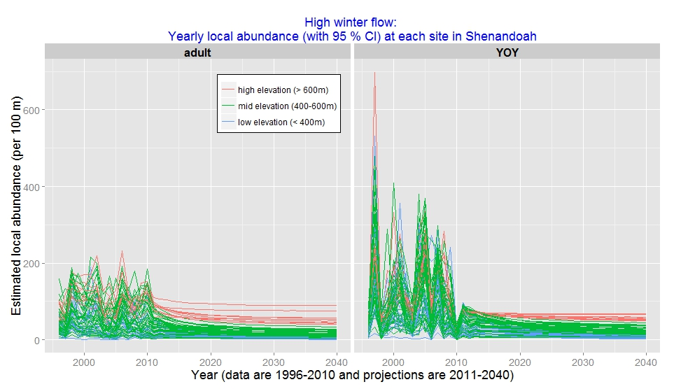
(b) Low fall flow
